# INTRODUCTION

## Overview

Food is essential for human life and has been the concern of many healthcare

conventions. Nowadays new dietary assessment and nutrition analysis tools

enable more opportunities to help people understand their daily eating habits,

exploring nutrition patterns and maintain a healthy diet. Nutritional analysis is

the process of determining the nutritional content of food. It is a vital part

of analytical chemistry that provides information about the chemical composition,

processing, quality control and contamination of food.

## Purpose

The main aim of the project is to building a model which is used for classifying the

fruit depends on the different characteristics like colour, shape, texture etc. Here the

user can capture the images of different fruits and then the image will be sent

the trained model. The model analyses the image and detect the nutrition based

on the fruits like (Sugar, Fibre, Protein, Calories, etc.).

# Proposed Solution

A model is trained on diverse images of fruits and is created using a convolution neural network. This model would let the users know the nutrition value of a particular fruit.

1. **System Architecture**
2. 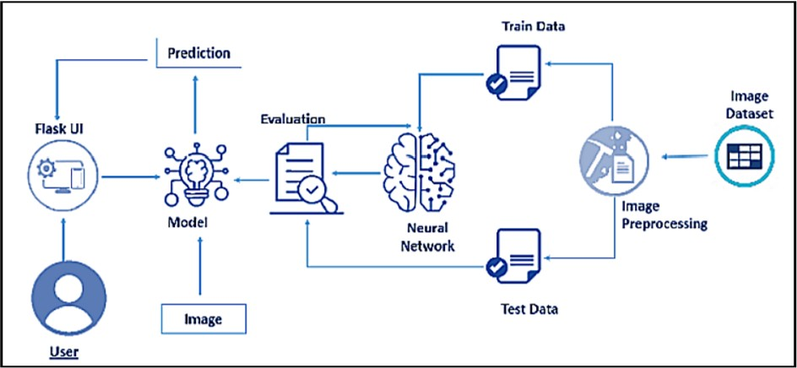**Hardware and Software Specifications**

**Hardware:**

Operating System : Windows, Mac, Linux

CPU : Multi Core Processors(i3 or above)

**Software:**

Python : v3.9.0 or above

Python Packages : tensorﬂow, ﬂask,keras, numpy, pandas

Web Browser :Mozilla Firefox,Internet Explorer, Google Chrome

IBM Cloud : Watson Studio - Model Training & Deployment as Machine Learning Instance

# Dataset

The dataset used contains five distinct classes of fruits.

The include - apples, bananas, pineapples, oranges, watermelons. The dataset has around

Images of fruits that are used for training and arounf 1000 images for testing the model.

# Experimental Investigation

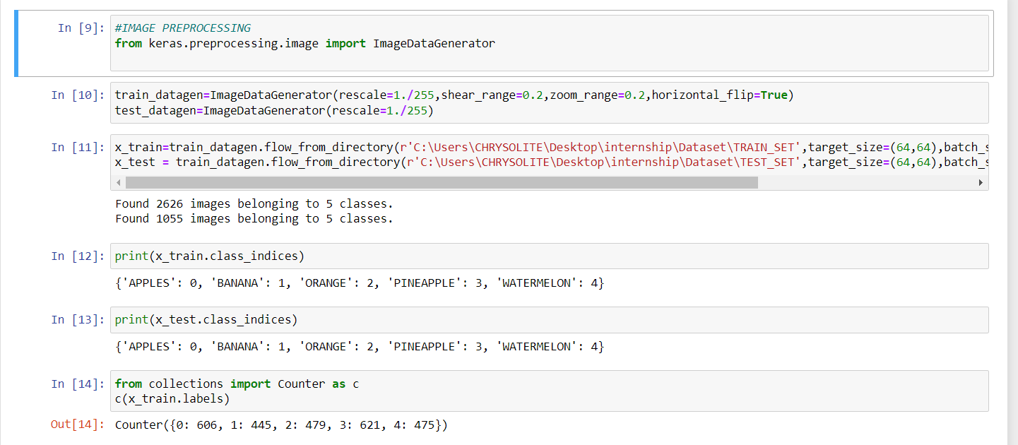

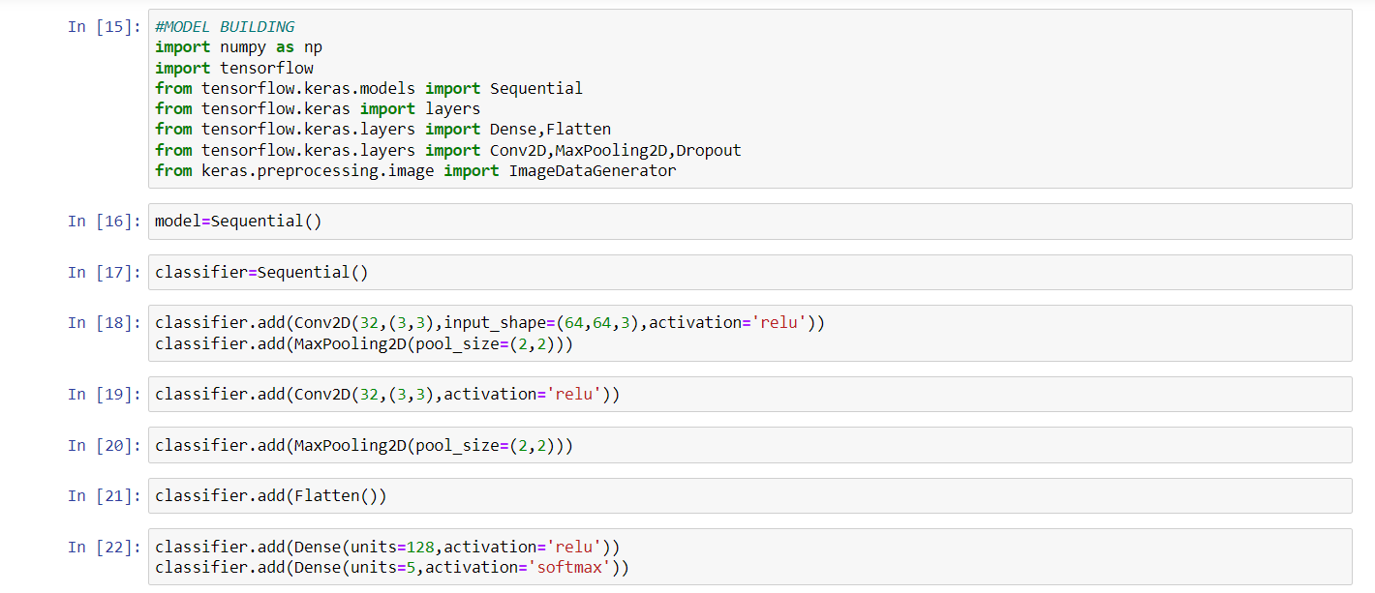

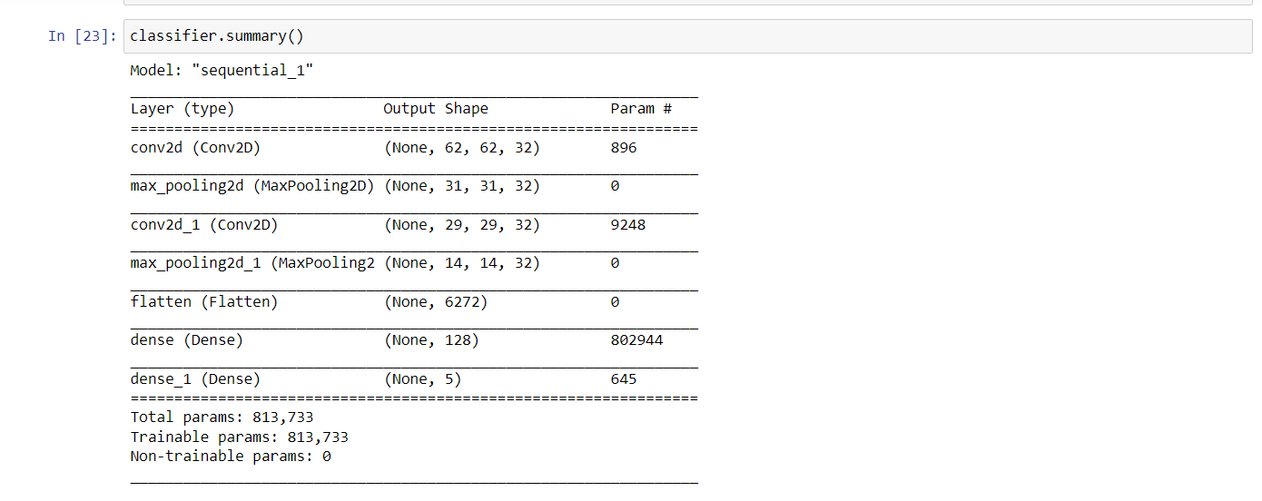

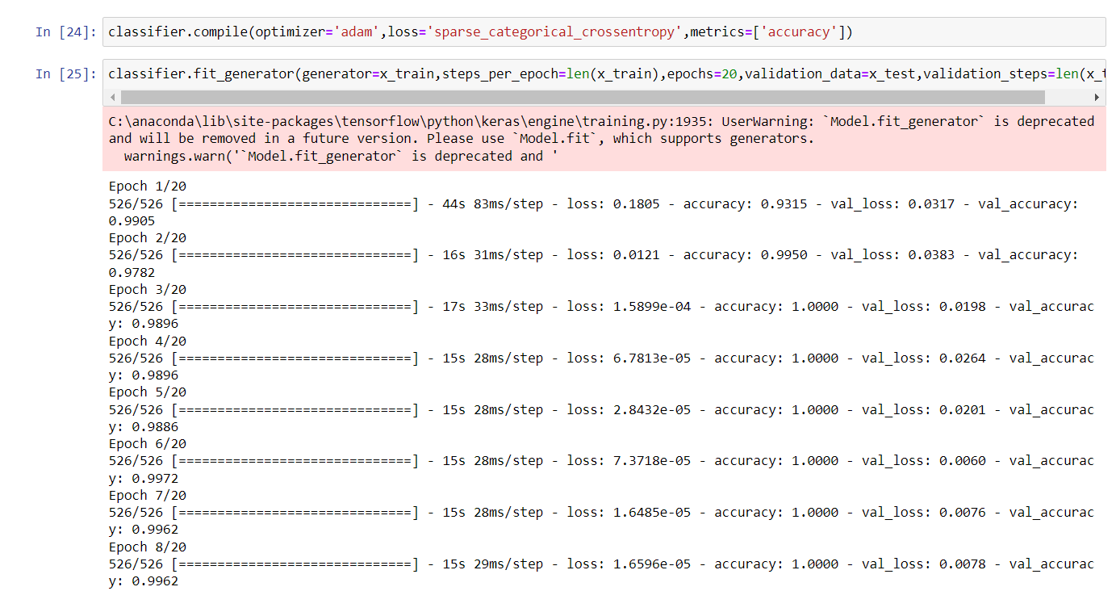

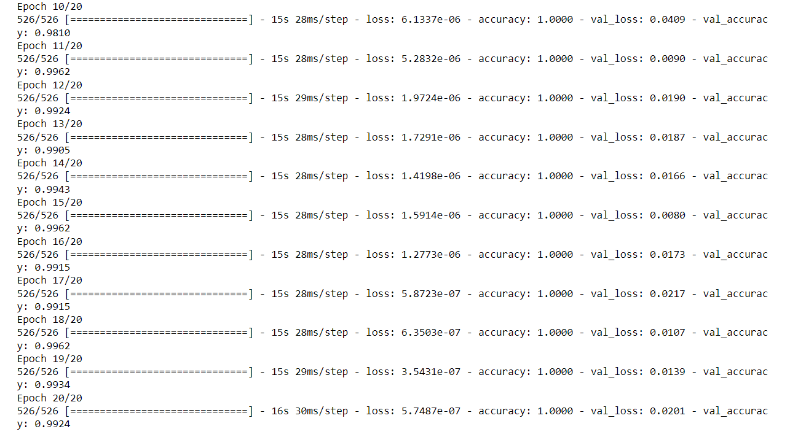

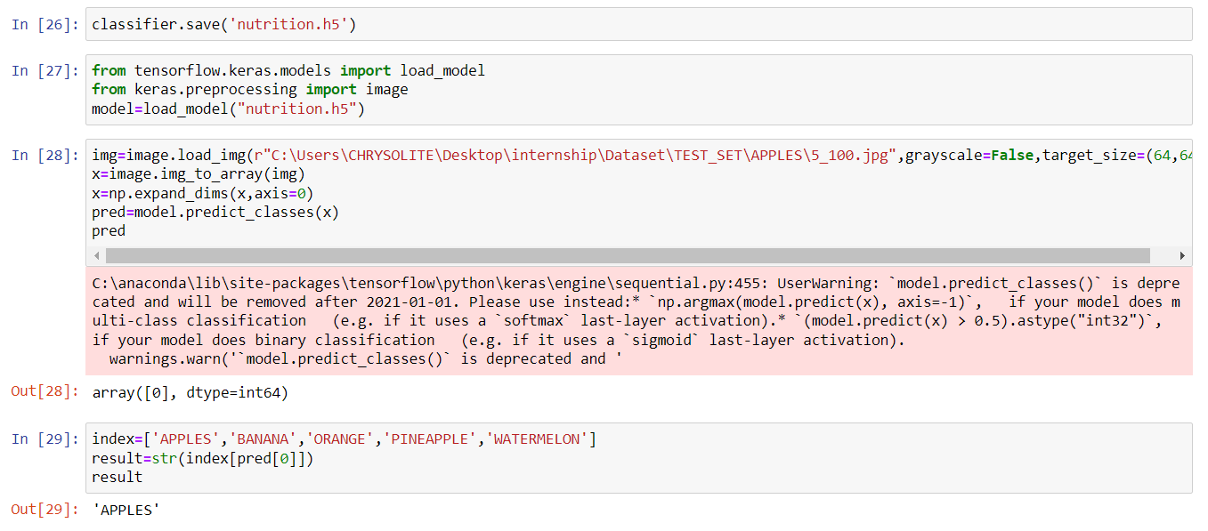

1. **Result**

A series of photos were used to implement and test the suggested approach. A set of 1055 images belonging to five classes - apples, bananas, oranges, pineapples and watermelons are utilised for the testing database, while a set of 2626 images are used for the training database as soon as the inpput image is recognised, the nutrition content of the fruit is displayed on the screen.

Below are some examples of the output images:

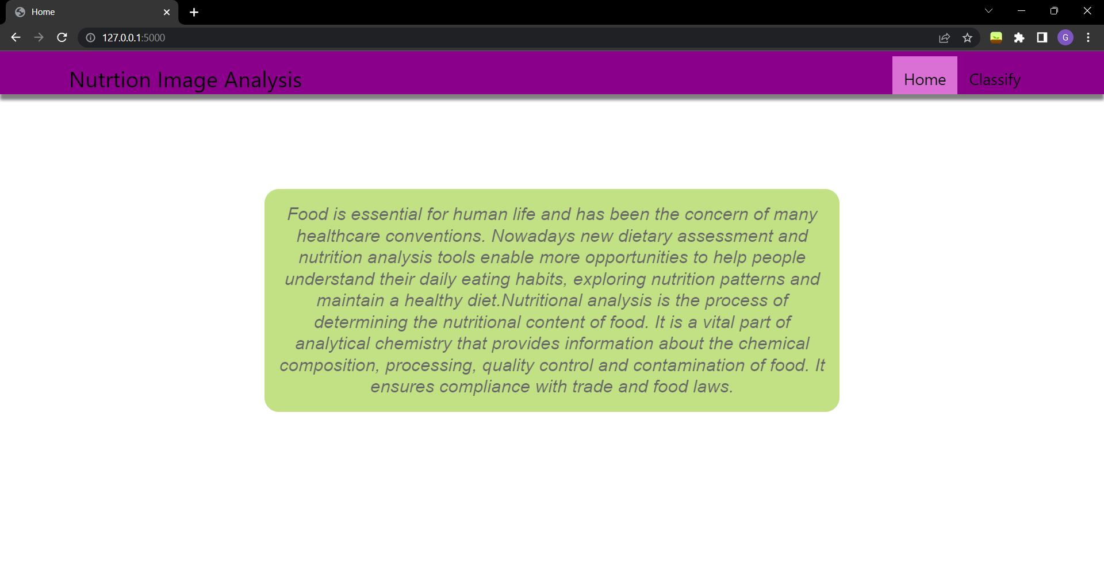

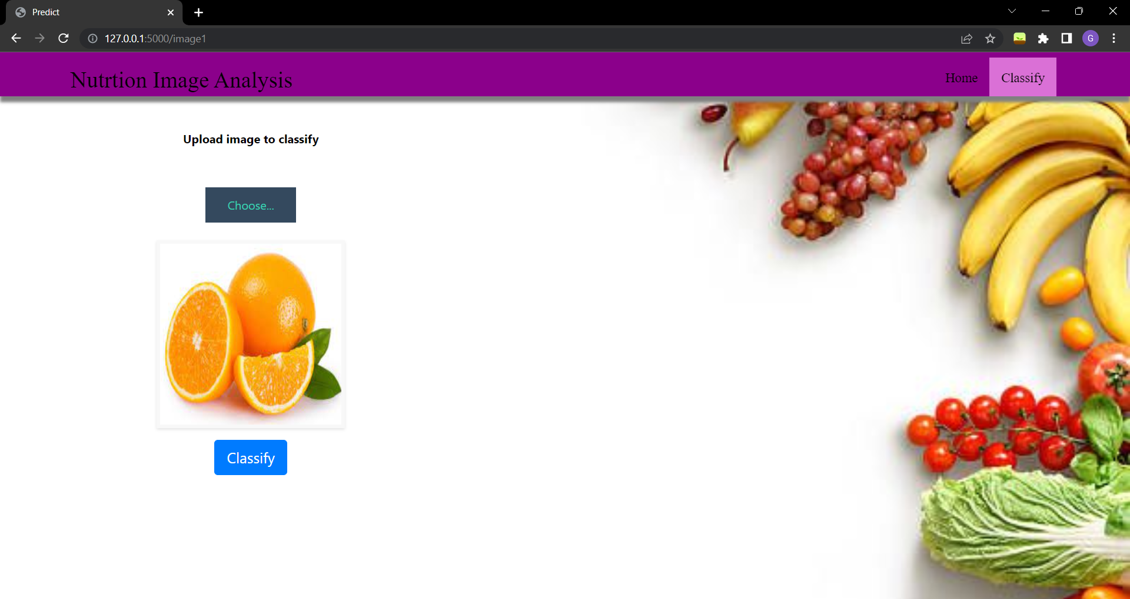

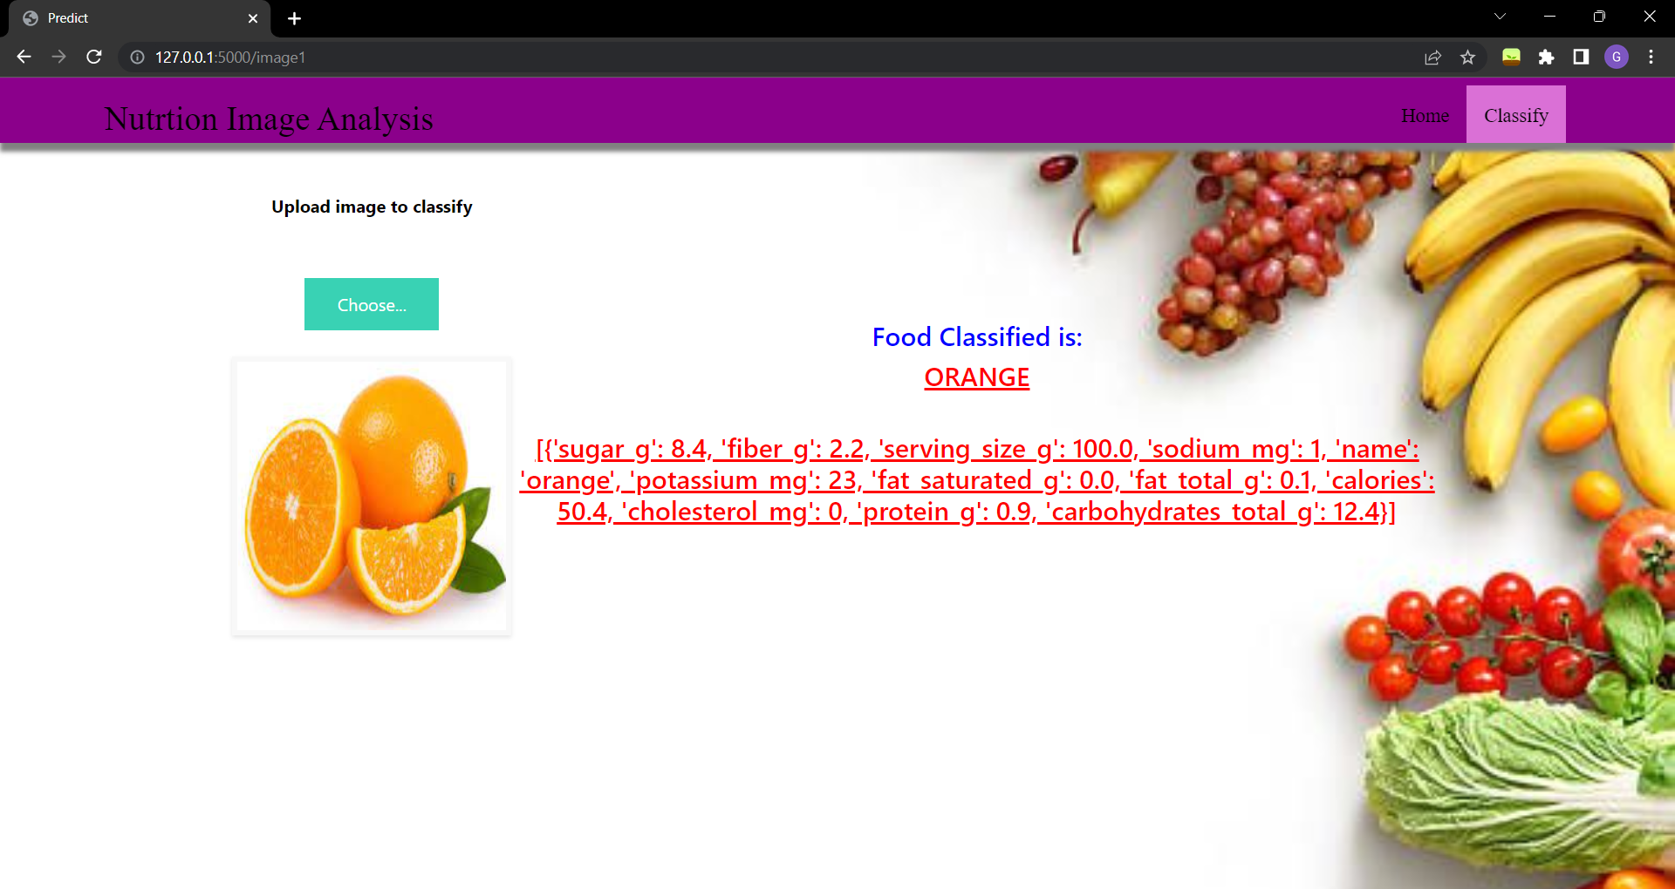

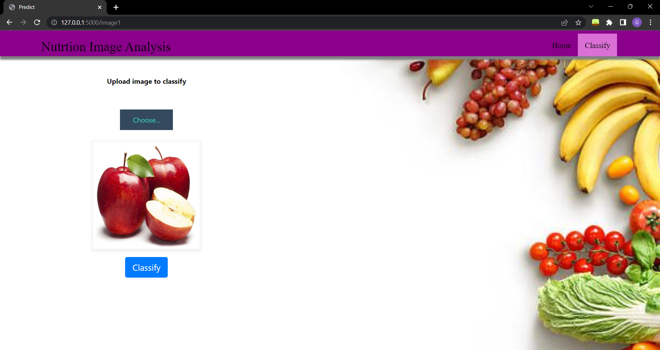

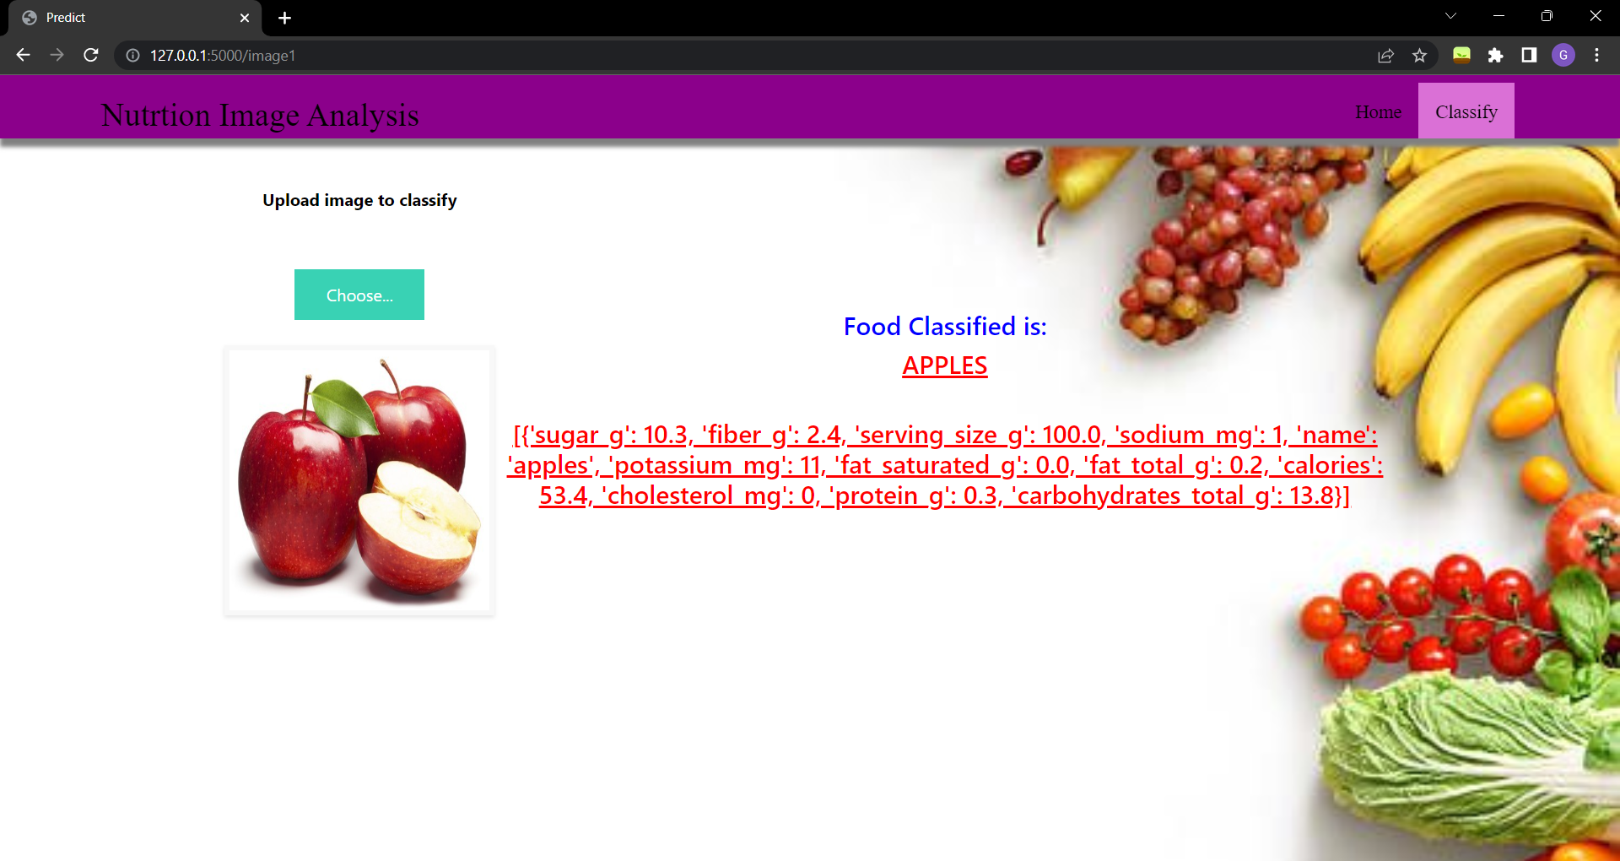

# Advantages and Disadvantages

**Advantages:**

1. An mobile application could be developed to help fitness enthusiasts analyze their nutrition.
2. The device does not require other external devices.Also Low cost, Convenient and easy to use.

**Disadvantages:**

1. The present model is able to predict nutrition content of only

a particular amount of fruit.For example, in 100 gm of fruit.

1. The quality of the dataset used is not eﬃcient, has a great impact

on the accuracy.

# Conclusion

The use of nutrition analyzer can help people especially who are concerned about their nutrition and are fitness enthusiasts to keep a track of and know the nutrition in the food that they consume. The technology strives to provide various aspects such as sugar, sodium, potassium contents in a serving size of 100 grams of a particular fruit.This system considers images of fruits as input, it recognizes the fruit and responds to by displaying the corresponding nutrition content.

# Future Scope

The system is designed to recognize only five classes of fruits which include apples, oranges, bananas, pineapples and watermelons. The system can be easily upgraded to recognize a wide variety of fruits and display their nutrtion values. Additionally, The system only provides nutrition value of a fixed serving size that is 100 grams. This can be scaled up and methods can be used such that the system provides the nutrition values based on the quantity of the fruit in the image given as input to the model.

# Bibilography

1. CNN using Tensorﬂow: https://[www.youtube.com/watch?v=umGJ30-15_A](http://www.youtube.com/watch?v=umGJ30-15_A)
2. Flask: https://[www.youtube.com/watch?v=lj4I_CvBnt0](http://www.youtube.com/watch?v=lj4I_CvBnt0)
3. IBM Cloud Account Creation: https://[www.youtube.com/watch?v=x6i43M7BAqE](http://www.youtube.com/watch?v=x6i43M7BAqE)
4. CNN Deployment and Download through

IBM Cloud:

https://[www.youtube.com/watch?v=BzouqMGJ41k](http://www.youtube.com/watch?v=BzouqMGJ41k)